c

|  |
| --- |
| Figure 1 A picture showing examples of smart accessories |
| SMART WEARABLE ACCESSORIES  COMPUTER APPLICATION TECHNOLOGY  Sir Baloyi  ENCS |
| |  |  |  | | --- | --- | --- | | Nesh Rachidi | Grade12 2025 | CAT PAT Phase 2 | |

|  |
| --- |
| Figure 2 Mind map of integration between applications Figure 1 A picture showing examples of smart accessories |
| SMART WEARABLE ACCESSORIES  COMPUTER APPLICATION TECHNOLOGY  Sir Baloyi  ENCS |
| |  |  |  | | --- | --- | --- | | Nesh Rachidi | Grade12 2025 | CAT PAT Phase 2 | |

TABLE OF FIGURES

Figure 1 A picture showing examples of smart accessories

Figure 2 Mind map of integration between applications Figure 1 A picture showing examples of smart accessories

Figure 2 Mind map of integration between applications 1

Figure 3 An example of the questionnaire that was filled out by participants 4

Figure 4 Picture showing examples of smart accessories 7

Figure 5 Screenshot of video showing difference between NFC and RFID technology 13

Figure 6 Screenshot showing how smart accessories can monitor health conditions 14

Figure 7 Picture showing improvement in the emission of radiation in cell phones 15

Figure 8 Screenshot describing one example of a theory explaining the relationship between consumers and willingness to pay 16

Figure 9 Screenshot of website where the advantages and disadvantages of smart accessories are discussed 17

Figure 10 Screenshot of the encyclopaedia website where whether the production of smart accessories should be made sustainable or not is discussed. 18

Figure 11 picture depicting a query of people who claim to be knowledgeable but use accessories for useless purposes 19

Figure 12 query extracting the most common solutions to improve the effectiveness of smart accessories 19

Figure 13 query that extracts the reasons, threats and whether or not people think they are effective 19

Figure 14Proof of export from my database to an excel spreadsheet (integration) ii

Figure 15 Further proof of export to excel ii

Figure 16 Proof of successful integration(successful export) iii

Figure 17 Proof of copying to be special pasted iii

Figure 18 Proof of paste link iv

Figure 19 Covert ion of table into icon iv

Figure 20 Screenshot of folder structure v

Figure 21 Scanned image of AI declaration vi

Figure 22 Screenshot of completed spelling and grammar check vii

TABLE OF CONTENTS

TABLE OF FIGURES i

TABLE OF CONTENTS ii

MINDMAP 1

framework, planning and intergration 1

INTRODUCTION 2

MAIN QUESTION/OBJECTIVE 2

QUESTIONS 3

QUESTIONNAIRE/SURVEY 4

QUESTIONs 5

open-ended questions 5

question tables 6

FINDINGS FROM QUERIES 19

PROCESS/DEVELOPMENT/COURSE OF ACTION 20

phase 1: 20

phase 2: 20

Task1: 20

TASK2: 20

CONCLUSION/EVALUATION 21

SELF-EVLUATION/FUTURE DEVELOPMENTS 22

PROOF OF INTERGRATION WITH OTHER PROGRAMS ii

APPENDICES v

addendum 1/folder structure v

Addendum 2/declaration of authenticity vi

Addendum 3/accuracy vii

BIBILIOGRAPHY viii

references viii

MINDMAP

framework, planning and intergration

Figure 2 Mind map of integration between applications

INTRODUCTION

The current problem is that technology is increasingly becoming advanced and in regards to wearable accessories the considerations and challenges of the everyday use of these smart technologies aren’t known to people. The general public has an adequate understanding on wearable technologies but lack a thorough understanding that could eventually benefit them. As of 2020 about 5.9% of people worldwide used wearable technologies. My focus will be on determining whether wearable accessories are currently effective or have the potential to be effective as well as comparing whether their benefits will outweigh the challenges they may pose. The purpose for this, is to find out about the usage of wearable accessories as well as find out how they may be able to ease the everyday lives of people. I will go about this investigation by researching the challenges and considerations of wearable accessories as well as finding possible solutions that may mitigate those issues. I will then gather and analyse the relevant data that answer my previous statement, this data will be grouped according the source it had been retrieved from as well as categories such as factual, comparative and investigative. I will then find reliable sources that answer these questions in their various categories. The data will be manipulated through applications such as Database Access, as well as Word Processor [1]and presented through a website. This information is for everyone, except children (about the age of 14 years and below) who want to improve their daily living by making certain task much easier to perform while providing other benefits to them that may or may not improve their lives.

MAIN QUESTION/OBJECTIVE

Considering the challenges involved in access to and usage of smart wearable accessories do they have the potential to be effective in the everyday lives of people globally?

QUESTIONS

|  |  |  |  |  |
| --- | --- | --- | --- | --- |
| No. | | Question | Type of Question | Category of question |
| 1. | | What is the definition of a smart accessory? | Closed | Factual |
| 2. | | What are some common examples of smart accessories? | Closed | Factual |
| 3. | | How much of the global population is knowledgeable on smart technologies? | Open | Investigative |
| 4. | | What are the most common uses for smart accessories? | Closed | Investigative |
| 5. | | What are the possible reasons one may purchase a smart accessory? | Open | Investigative |
| 6. | | What kind of threats, conflicts or challenges do you think smart technologies can impose on your personal life? | Open | Investigative |
| 7. | | Is it effective or ineffective to use smart accessories in our daily lives? | Open | Comparison |
| 8. | | How do smart accessories monitor vital signs (e.g., heart rate, blood pressure)? | Open | Investigative |
| 9. | | What are the types of biometric sensors used in smart wearables? | Closed | Investigative |
| 10. | | How is NFC technology different from RFID technology in smart accessories? | Open | Investigative |
| 11. | | How can smart accessories monitor and manage chronic health conditions? | Open | Investigative |
| 12. | | If there is a growing concern for the health impacts of electromagnetic radiation, then what would happen to the demand for smart accessories with reduced radiation emissions? | Open | Change |
| 13. | | What theory explains the relationship between smart accessory features and consumer willingness to pay? | Open | Change |
| 14. | | What are the advantages or disadvantages of the integration of smart accessories into peoples’ everyday lives? | Closed | Comparison |
| 15. | | Should smart accessories be designed with environmental sustainability in mind? Why or why not? | Open | Comparison |
| Total | 15 |  |  |  |

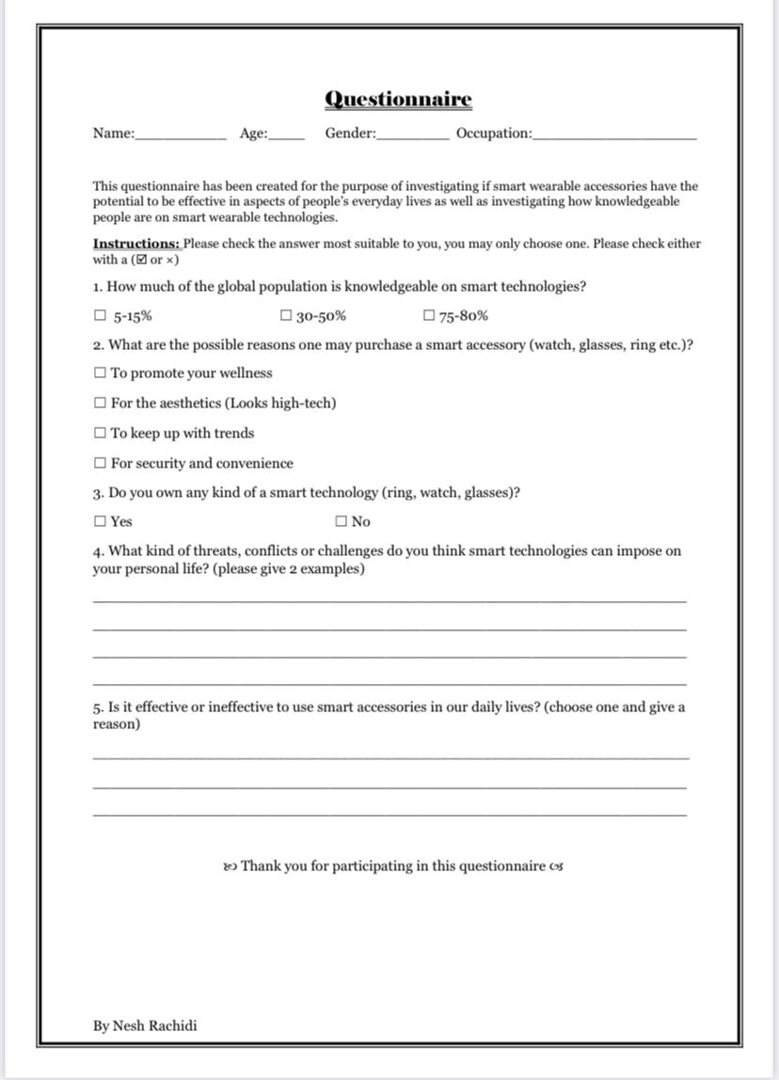QUESTIONNAIRE/SURVEY

Figure 3 An example of the questionnaire that was filled out by participants

QUESTIONs

open-ended questions

* How much of the global population is knowledgeable on smart technologies?
* What are the possible reasons one may purchase a smart accessory?
* What kind of threats, conflicts or challenges do you think smart technologies can impose on your personal life?
* Is it effective or ineffective to use smart accessories in our daily lives?
* How do smart accessories monitor vital signs (e.g., heart rate, blood pressure)?
* How is NFC technology different from RFID technology in smart accessories?
* How can smart accessories monitor and manage chronic health conditions?
* If there is a growing concern for the health impacts of electromagnetic radiation, then what would happen to the demand for smart accessories with reduced radiation emissions?
* What theory explains the relationship between smart accessory features and consumer willingness to pay?
* Should smart accessories be designed with environmental sustainability in mind? Why or why not?closed-ended questions
* What is the definition of a smart accessory?
* What are some common examples of smart accessories?
* What are the most common uses for smart accessories?
* What are the types of biometric sensors used in smart wearables?
* What are the advantages or disadvantages of the integration of smart accessories into peoples’ everyday lives?

question tables

|  |  |
| --- | --- |
| Question 1 | What is the definition of a smart accessory? |
| Open/Closed | Closed |
| Category | Factual |
| Methods and Sources | Website |
| Plan/Strategy for searching | Use keywords such as “define”, “smart” and “accessory” to define a smart accessory on Google Chrome |
| Package used to organise data | Database and Website |
| Answer to question | Any kind of electronic device designed to be worn on the user's body. Such devices can take many different forms, including jewellery, accessories, medical devices, and clothing or elements of clothing. |
| Evidence Bookmark to screen dump/ Reference to Appendix | Kinza Yasar[2], one of the authors is a technical writer with a degree in computer networking and numerous IT certifications. Therefor she is more than qualified to give valid information and research on the given topic. |
| How/Why information will be used | **Why:** Identifying what a smart accessory will help identify the problems and solutions specific to accessories.  **How:** Will be used to identify the types of smart accessories and gather more accurate data specifically on smart *accessories* and not technologies in general. |
| Citation of reference | (Yasar & Wigmore, n.d.) [[click here]](https://www.techtarget.com/searchmobilecomputing/definition/wearable-technology#:~:text=Wearable%20technology%20is%20any%20kind,clothing%20or%20elements%20of%20clothing.) |
| Proof authenticity | Information was posted and co-written by Kinza Yasar who has a degree in computer networking and numerous IT certificates hence her work counts as an authentic source. |

|  |  |
| --- | --- |
| Question 2 | What are some common examples of smart accessories? |
| Open/Closed | Closed |
| Category | Factual |
| Methods and Sources | YouTube Video |
| Plan/Strategy for searching | Use of keywords such as “example”, “smart accessory” on YouTube |
| Package used to organise data | Database and Website |
| Answer to question | * Smart Watch * Smart Sunglasses * Smart Hat * Augmented Reality Glasses |
| Evidence Bookmark to screen dump/ Reference to Appendix | Figure 4 Picture showing examples of smart accessories |
| How/Why information will be used | **Why:** In order to identify exactly which accessories are relevant to research as well as their specific challenges and potential effectiveness.  **How:** More research will be done on these specific accessories on how they can ease our everyday lives and their specific challenges |
| Citation of reference | (9 Wearable Smart Accessories For Your Everyday Lifestyle, 2023) [[click here]](https://www.youtube.com/watch?v=4kRaO8bB-so) |
| Proof authenticity | The film/video was made by a company named Trends Place, which namely focuses on today’s dynamic world on current business, social media, etc.,. |

|  |  |
| --- | --- |
| Question 3 | How much of the global population is knowledgeable on smart technologies? |
| Open/Closed | Open |
| Category | Investigative |
| Methods and Sources | Questionnaire |
| Plan/Strategy for searching | Questionnaires filled out by people |
| Package used to organise data | Database and Website |
| Answer to question | 75-80% |
| Evidence Bookmark to screen dump/ Reference to Appendix | Most questionnaires filled in by people chose mostly the last option |
| How/Why information will be used | **Why:** Will be used to get a general concise of how much the public thinks they know on smart technology.  **How:** Will be used to determine which groups of people (age, gender, etc.,.) fall under the majority. |
| Citation of reference | (Itu, et al., 2025)  [click here] |
| Proof authenticity | Information is useable as the data was received from actual people and done recently |

|  |  |
| --- | --- |
| Question 4 | What are the most common uses for smart accessories? |
| Open/Closed | Closed |
| Category | Investigative |
| Methods and Sources | Online encyclopaedia |
| Plan/Strategy for searching | Use of keywords such as: “common”; “smart” and “accessories” on Wikipedia |
| Package used to organise data | Database and Website |
| Answer to question | * In professional sports, wearable technology has applications in monitoring and real-time feedback for athletes. * In cybersecurity and financial technology, secure wearable devices have captured part of the physical security key market. |
| Evidence Bookmark to screen dump/ Reference to Appendix | * Used in professional sports (e.g. pedometers) * Used in health informatics (e.g. better learning algorithms to analyse health condition of users) |
| How/Why information will be used | **Why:** To find out the challenges that come with the uses in these categories and find solutions so they become more effective.  **How:** Will be used to determine solutions to the problems that people might face using these accessories. |
| Citation of reference | (Wikipedia, 2024) [[click here]](https://en.wikipedia.org/wiki/Pulse_watch?utm_.com) |
| Proof authenticity | It was last updated on the 20 February 2025 at 17:51 by EntropyReducingGuy. It was published on 28 July 2009 by ChildoMidnight. |

|  |  |
| --- | --- |
| Question 5 | What are the possible reasons one may purchase a smart accessory? |
| Open/Closed | Open |
| Category | Investigative |
| Methods and Sources | Questionnaire |
| Plan/Strategy for searching | Questionnaires filled out by people |
| Package used to organise data | Database and Website |
| Answer to question | Between:   1. For the aesthetics (Looks high-tech) 2. To keep up with trends 3. For security and convenience |
| Evidence Bookmark to screen dump/ Reference to Appendix | Most of the questionnaires filled out these 3 options in equal amount of choices. |
| How/Why information will be used | **Why:** Will be used to find out the general reasons for purchasing smart accessories as well as a way to use them more effectively in peoples’ lives.  **How:** Will be used to determine if people know that smart accessories can offer much more than eye pleasure and actually help them and better their lives. |
| Citation of reference | (Lwandle, et al., 2025)  [click here] |
| Proof authenticity | Information is useable as the data was received from actual people and done recently. |

|  |  |
| --- | --- |
| Question 6 | What kind of threats, conflicts or challenges do you think smart technologies can impose on your personal life? |
| Open/Closed | Open |
| Category | Investigative |
| Methods and Sources | Questionnaire |
| Plan/Strategy for searching | Questionnaires filled out by people |
| Package used to organise data | Database and Website |
| Answer to question | * Invasion of privacy * Cyberbullying * Time-management/procrastination * Maintenance/Expensive |
| Evidence Bookmark to screen dump/ Reference to Appendix | Most people who filled out the questionnaires filled out options similar to these points. |
| How/Why information will be used | **Why:** To discover the man reasons why smart technologies aren’t effective as they should be.  **How:** Will be used to determine methods which enable these smart accessories to be more effective in people’s lives. |
| Citation of reference | (Lwandle, et al., 2025)  [click here] |
| Proof authenticity | Information is useable as the data was received from actual people and done recently. |

|  |  |
| --- | --- |
| Question 7 | Is it effective or ineffective to use smart accessories in our daily lives? |
| Open/Closed | Open |
| Category | Comparison |
| Methods and Sources | Questionnaire |
| Plan/Strategy for searching | Questionnaires filled out by people |
| Package used to organise data | Database and Website |
| Answer to question | Effective, as they can improve the quality of our daily lives and be more convenient with our tasks as well as helping with our monitoring or health and fitness goals. |
| Evidence Bookmark to screen dump/ Reference to Appendix | Most people who filled out the questionnaires filled out options similar to these points. |
| How/Why information will be used | **Why:** It helped identify possible problems and challenges in relation to smart accessories.  **How:** With this information I will be able to find effective solutions and present these findings. |
| Citation of reference | (Lwandle, et al., 2025)  [click here] |
| Proof authenticity | Information is useable as the data was received from actual people and done recently. |

|  |  |
| --- | --- |
| Question 8 | How do smart accessories monitor vital signs (e.g., heart rate, blood pressure)? |
| Open/Closed | Open |
| Category | Investigative |
| Methods and Sources | Website |
| Plan/Strategy for searching | Using keywords such as: ”Monitor”, “vital” and “website” |
| Package used to organise data | Database and Website |
| Answer to question | Most smartwatches use a technique called photoplethysmography. Basically, it uses light (photo) to record (graphy) changes in the volume (plethysmo) of your blood vessels. Most smartwatches accomplish this with a green LED and a photodetector. |
| Evidence Bookmark to screen dump/ Reference to Appendix | The author of this blog has been reporting newspapers, magazines and blogs for over 20 years. So he has had enough experience to write about important events. |
| How/Why information will be used | **Why:** To determine if these accessories have the potential to positively after people’s health  **How:** I will find solutions to these matters |
| Citation of reference | (Allen, 2023) [[click here]](https://www.androidpolice.com/fitness-trackers-smartwatches-meaure-vitals-explainer/) |
| Proof authenticity | Was published by Allen Daniel who has had over 20 years’ experience, therefore he is more than qualified. |

|  |  |
| --- | --- |
| Question 9 | What are the types of biometric sensors used in smart wearables? |
| Open/Closed | Closed |
| Category | Investigative |
| Methods and Sources | Online encyclopaedia |
| Plan/Strategy for searching | Using keywords such as “biometric”, “sensors” and “smart wearables” |
| Package used to organise data | Database and Website |
| Answer to question | * Optical emitters * Processors * Accelerometer |
| Evidence Bookmark to screen dump/ Reference to Appendix | * Algorithms-formed from the processor & the accelerometer into biometric data. Data such as blood pressure and calorie intake can also be provided to the user. * Optical emitters- LEDs send coloured light waves into the skin. |
| How/Why information will be used | **Why:** It will establish a better understanding of how sensors function and how they can improve our daily activities.  **How:** It will be used to better current sensors to avoid any complications or threats. |
| Citation of reference | (Wikipedia, 2024) [[click here]](https://en.wikipedia.org/wiki/Pulse_watch?utm_.com) |
| Proof authenticity | It was last updated on the 7 February 2024 at 04:42. |

|  |  |
| --- | --- |
| Question 10 | How is NFC technology different from RFID technology in smart accessories? |
| Open/Closed | Open |
| Category | Investigative |
| Methods and Sources | YouTube |
| Plan/Strategy for searching | Keywords such as “difference” ; “NFC” and “RFID” |
| Package used to organise data | Database and Website |
| Answer to question | * RFID: can work over longer distances and commonly used for inventory * NFC: can only work .in close-proximity and adopted in smart phones can be used for contactless payment. |
| Evidence Bookmark to screen dump/ Reference to Appendix | Figure 5 Screenshot of video showing difference between NFC and RFID technology |
| How/Why information will be used | **Why:** It is a consideration to be made which ca impact the possible solutions one may have for their accessories.  **How:** The information will impactwhich kind of smart accessories to use depend. |
| Citation of reference | (NFC vs RFID, What' s the difference, 2023)[[click here]](https://www.youtube.com/watch?v=m0wXeSxQj9I) |
| Proof authenticity | Information is usable as the channel focuses on the latest business technology and IT topics, including AI, cybersecurity, networking, cloud, storage, sustainability and more. |

|  |  |
| --- | --- |
| Question 11 | How can smart accessories monitor and manage chronic health conditions? |
| Open/Closed | Open |
| Category | Investigative |
| Methods and Sources | Online encyclopaedia |
| Plan/Strategy for searching | Use keywords such as :”Manage”; “conditions” and” monitor” |
| Package used to organise data | Database and Website |
| Answer to question | Withings[3] released the first connected blood pressure monitor, which was upgraded in March 2014 to a wireless version to connect to iOS and Android mobile devices.[50] Approved by the FDA, the device allows patients to chart their blood pressure readings at home. |
| Evidence Bookmark to screen dump/ Reference to Appendix | E:\CAT\PAT (gr12)\Rachidi Nesh 12F PAT\Phase 1\Sources\Open-ended questions' sources\que11-2.png  Figure 6 Screenshot showing how smart accessories can monitor health conditions |
| How/Why information will be used | **Why:** So that these accessories can inform us on the health possible threats.  **How:** It will be used to form tables of expression on the benefits of being able to monitor your health 24/7. |
| Citation of reference | (Carreel, et al., n.d.) [[click here]](https://en.wikipedia.org/wiki/Withings?utm_.com) |
| Proof authenticity | It was founded in June 2008 and updated last on the 17th of January 2025, at 10:39 |

|  |  |
| --- | --- |
| Question 12 | If there is a growing concern for the health impacts of electromagnetic radiation, then what would happen to the demand for smart accessories with reduced radiation emissions? |
| Open/Closed | Open |
| Category | Change |
| Methods and Sources | Blog |
| Plan/Strategy for searching | Use keyword such as :”concern”, “electromagnetic radiation” and “reduced” |
| Package used to organise data | Database and Website |
| Answer to question | Heightened awareness of the potential health risks associated with electromagnetic radiation is driving consumer demand for smart accessories with reduced radiation emissions. Manufacturers are responding by developing products that prioritize user safety, indicating a market shift towards low-radiation devices. |
| Evidence Bookmark to screen dump/ Reference to Appendix | E:\CAT\PAT (gr12)\Rachidi Nesh 12F PAT\Phase 1\Sources\Open-ended questions' sources\que12.png  Figure 7 Picture showing improvement in the emission of radiation in cell phones |
| How/Why information will be used | **Why:** It could serve as a possible solution to the growing risks of radiation**.**  **How:** It will be used as a possible solution to some considerations |
| Citation of reference | (Anon., n.d.) [[click here]](https://emfacademy.com/lowest-radiation-cell-phones/?utm_source=.com) |
| Proof authenticity | It was last updated on December 17, 2024 |

|  |  |
| --- | --- |
| Question 13 | What theory explains the relationship between smart accessory features and consumer willingness to pay? |
| Open/Closed | Open |
| Category | Change |
| Methods and Sources | Journal Article |
| Plan/Strategy for searching | Use keywords such as : “theory” ; ”relationship” and “consumer” |
| Package used to organise data | Database and Website |
| Answer to question | * **Technology Acceptance Model (TAM**): suggests that perceived usefulness and ease of use influence consumers' intentions to adopt new technologies * **Social Influence and Visibility**: The desire to own products that are perceived as status symbols or are popular among peers can drive willingness to pay. |
| Evidence Bookmark to screen dump/ Reference to Appendix | Figure 8 Screenshot describing one example of a theory explaining the relationship between consumers and willingness to pay |
| How/Why information will be used | **Why:** These theories suggest that the relationships between the consumer and producer affect the production of smart accessories and ultimately the percentage of people who become knowledgeable enough to benefit from these technologies.  **How:** It will be used to determine how to influence the future population to use smart accessories to their advantage and be effective in their lives. |
| Citation of reference | (Almuraqab, 2021) [[click here]](https://www.astesj.com/v06/i01/p142/?utm_source=#1646744995334-bbe76587-422b) |
| Proof authenticity | Published by Nasser Abdo Saif Almuraqab |

|  |  |
| --- | --- |
| Question 14 | What are the advantages or disadvantages of the integration of smart accessories into peoples’ everyday lives? |
| Open/Closed | Closed |
| Category | Comparison |
| Methods and Sources | Blog |
| Plan/Strategy for searching | Use keywords such as: “advantages” , “disadvantages” and “smart technologies” |
| Package used to organise data | Database and Website |
| Answer to question | * ADVANTAGES:   + **Better Healthcare**: Wearable smart devices, such as heart and fitness trackers, provide precise, blood pressure monitors, and real-time health data.   + **Efficiency and Productivity have Increased:** sensors that allow you to monitor valuable resources such as inventory, fuel, and available spare parts. |
| Evidence Bookmark to screen dump/ Reference to Appendix | Figure 9 Screenshot of website where the advantages and disadvantages of smart accessories are discussed |
| How/Why information will be used | **Why:** Can help determine exactly how beneficial smart accessories can be by comparing their pros and cons.  **How:** Pros and cons will be weighed to determine their value |
| Citation of reference | (techlywse, 2024) [[click here]](https://techlywise.com/smart-devices-features-advantages-disadvantages/) |
| Proof authenticity | Article written by a corporate author of the periodical (techlywise) |

|  |  |
| --- | --- |
| Question 15 | Should smart accessories be designed with environmental sustainability in mind? Why or why not? |
| Open/Closed | Open |
| Category | Comparison |
| Methods and Sources | Online encyclopaedia |
| Plan/Strategy for searching | Use keywords such as: “environmental” , “sustainable” and “design” |
| Package used to organise data | Database and Website |
| Answer to question | * **WHY:**   + Sustainable design seeks to reduce negative impacts on the environment, the health and well-being of building occupants, thereby improving building performance**.** * **WHY NOT:**   + The designer is responsible for choices that place a demand on natural resources, produce waste, and potentially cause irreversible ecosystem damage. |
| Evidence Bookmark to screen dump/ Reference to Appendix | Figure 10 Screenshot of the encyclopaedia website where whether the production of smart accessories should be made sustainable or not is discussed. |
| How/Why information will be used | **Why:** It will be used to determine how future smart accessories will be made and how their production will affect the sustainability of the environment.  **How:** The information will be used to compare whether or not smart accessories should be made eco-friendly . |
| Citation of reference | (Wikipedia, 2020) [[click here]](https://en.wikipedia.org/wiki/Sustainable_design) |
| Proof authenticity | Written by a corporate author of the article (Wikipedia) |

FINDINGS FROM QUERIES

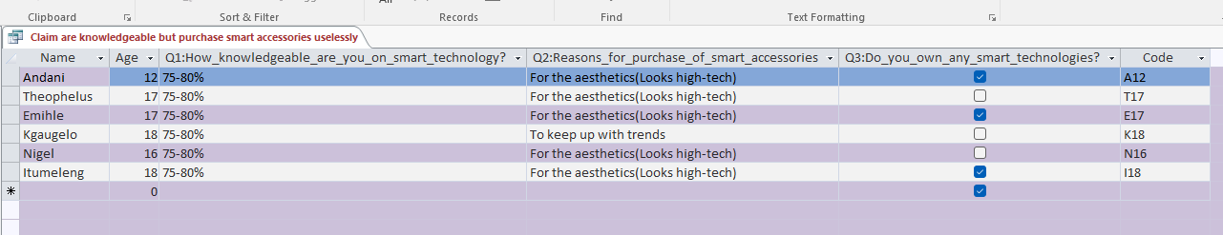

Figure 11 picture depicting a query of people who claim to be knowledgeable but use accessories for useless purposes

This query extracts the result of people who claim to be knowledgeable on smart accessories but their main reason for the purchase is not due to anything substantial.

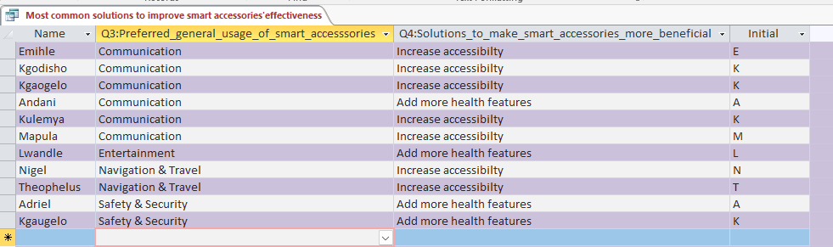

Figure 12 query extracting the most common solutions to improve the effectiveness of smart accessories

Query extracts results of the most common solutions which can be used to improve the effectiveness of smart accessories in the everyday lives of people.

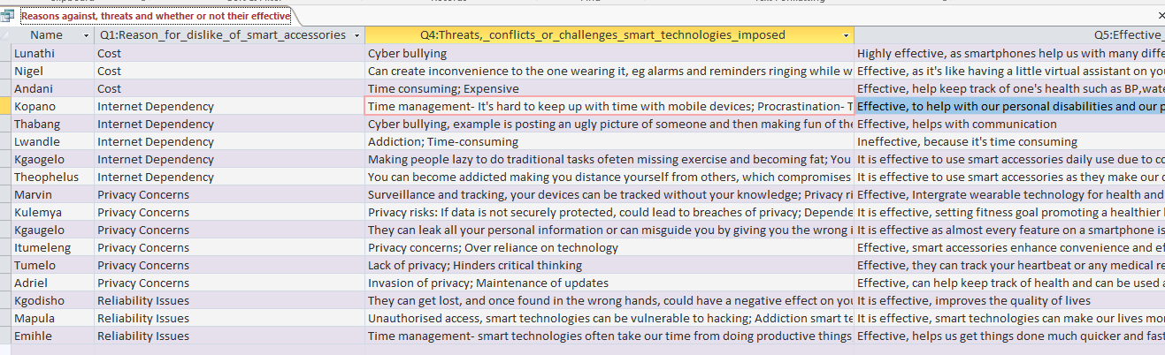

Figure 13 query that extracts the reasons, threats and whether or not people think they are effective

Query extracts the results of the most common threats as well as the reason for the dislike of smart accessories. The results ultimately extract that regardless of all the threats and challenges, smart accessories are still effective to be used in the everyday lives of people

PROCESS/DEVELOPMENT/COURSE OF ACTION

phase 1:

I wanted to insert different page numbers but the section breaks made that difficult for me. The advantage is that it allowed me to separate my appendices, bibliography and tables of content and figures from the rest of the documents.

phase 2:

Task1:

With my database, I had never learnt how to create a relationship between tables, which I needed to create in order to create one of my queries. Its advantage was that it allowed me to extract related information from two separate tables in order to create a query that would aid in providing a solution.

Another struggle was with one of the reports, which didn’t highlight the results of all the records.

TASK2:

With my webpage, I wanted to put a search engine but there was an error in the code somewhere in the notepad. Once I deleted an unnecessary element, the code was fixed and the search engine worked. The advantage of it was that I did not need to create a table of contents because it was replaced by the search engine.

CONCLUSION/EVALUATION

As seen from the two reports in the database,

one can see that one speaks of how people would prefer to use smart accessories as well as why they would be effective or ineffective

❶in terms of their usage most people preferred for smart accessories to be used for:

* Communication
  + To receive calls, texts, email and notifications directly on their accessories
  + As well as to allow voice commands and even standalone calling or messaging.
* Safety & Security
  + For emergency SOS functions or fall detection.
  + As well as location tracking for kids, the elderly, or pets.

This goes in hand with how the people chose that smart accessories in general tend to be effective as they offer a variety of useful information that can keep us as well as our data safe and allow us to communicate with our loved ones.

In the second report, the threats of smart accessories can be seen as well as their solutions in order for them to truly be effective in the everyday lives of people.

②Common threats that smart accessories impose are:

* Invasion of privacy/privacy risks
* Maintenance of updates
* Cyberbullying/Lack of privacy

These coincide with the common solutions that were offered by people which included:

* Prioritising data privacy & security
  + **Solution**: Encrypt data, provide clear privacy settings, and limit third-party access.
    - **Impact:** Builds user trust, especially when handling sensitive health, location data or protecting victims of cyberbullying.
* Increasing accessibility
  + **Solution:** Design with inclusive features—voice commands, larger interfaces, and haptic feedback.
    - **Impact:** Makes smart accessories usable for people with disabilities or different age groups
* Regular updates and maintenance
  + **Solution:** Provide consistent software and firmware updates to fix bugs, enhance security, and introduce new features.
    - **Impact:** Keeps the accessory functional, secure, and relevant over time, reducing the need for frequent replacements and improving long-term user satisfaction.

SELF-EVLUATION/FUTURE DEVELOPMENTS

I have learnt so during the duration of this Common Assessment Task. Not only technically but on the topic itself. This Assessment has given me the opportunity to polish up my word processing as well as html skills. I hope to be able to apply the knowledge I learnt in my own personal projects. In terms of the topic, I have learnt that with the development of technology, it has been able to afford people with multiple benefits such as health tracking, communication and privacy and security I also believe that if people become more knowledgeable on smart accessories, they would have effective results in their daily live

**Table showing** **Table 3** **from Database**



PROOF OF INTERGRATION WITH OTHER PROGRAMS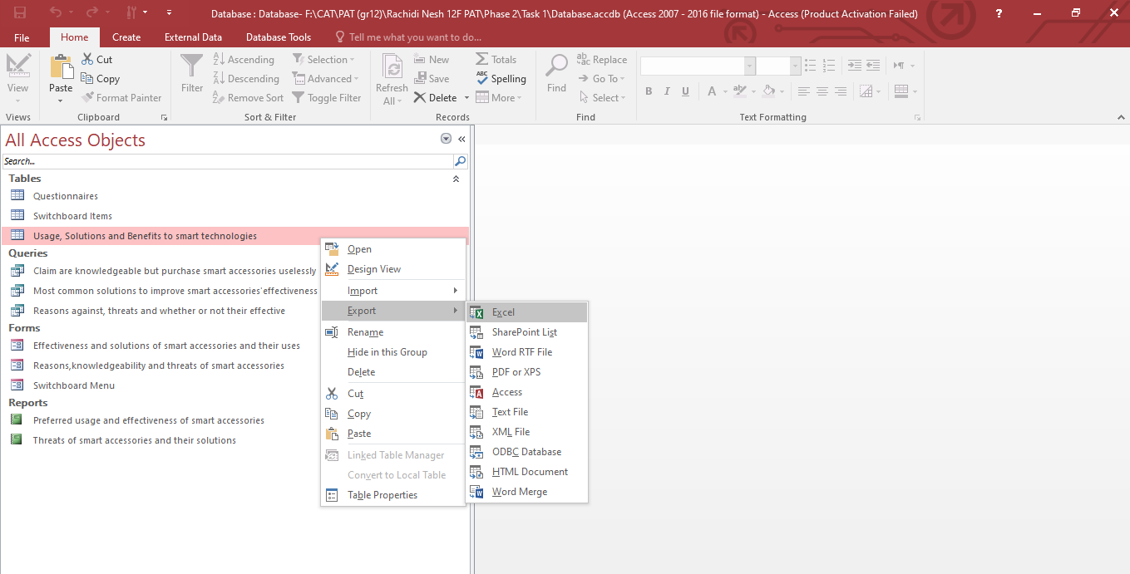

Figure 14Proof of export from my database to an excel spreadsheet (integration)

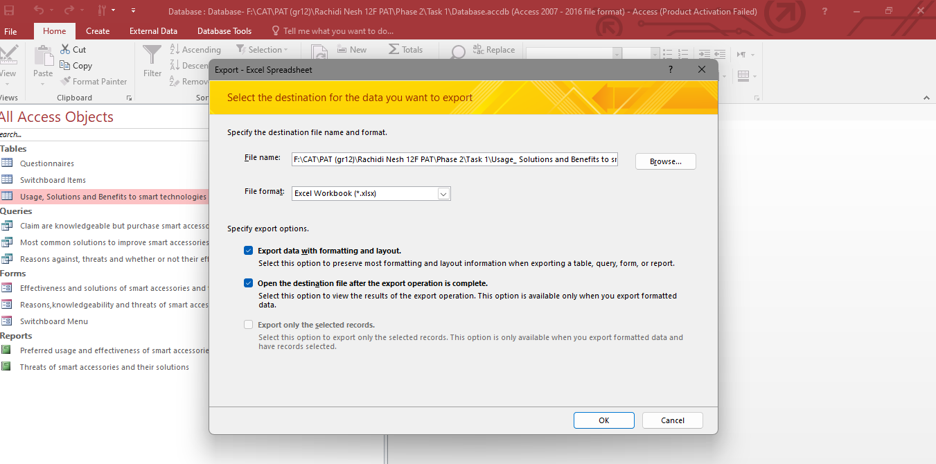

Figure 15 Further proof of export to excel

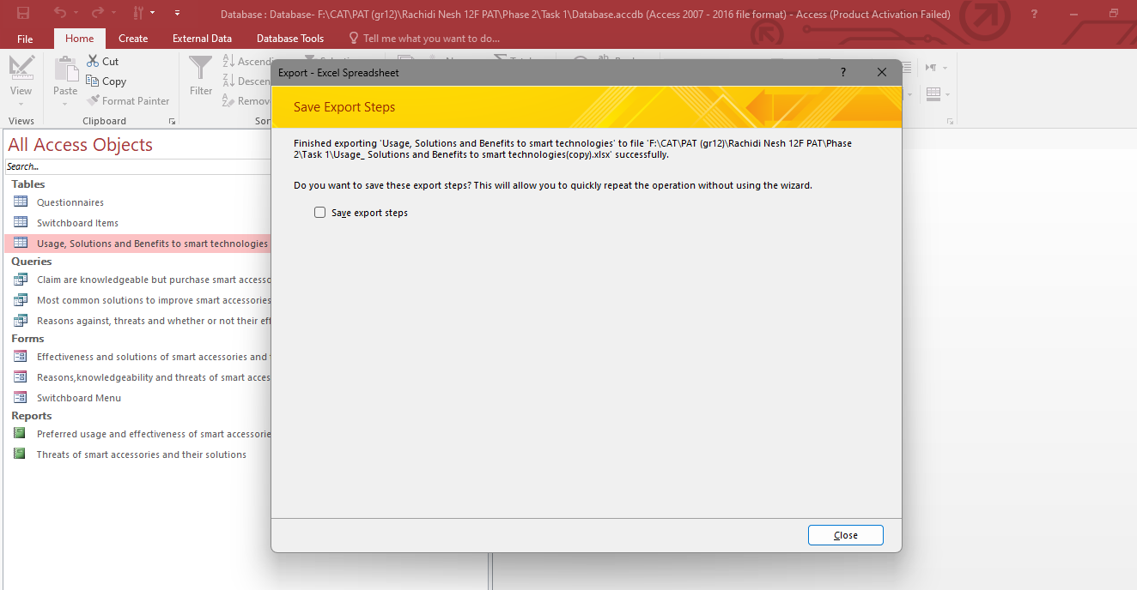

Figure 16 Proof of successful integration(successful export)

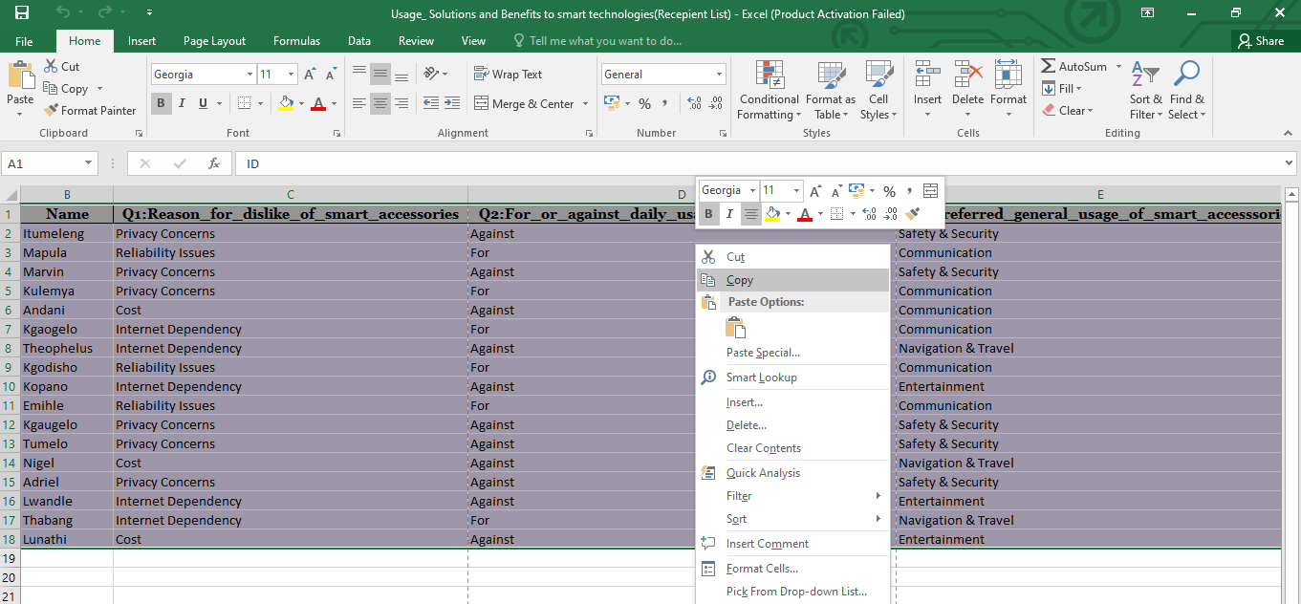

Figure 17 Proof of copying to be special pasted

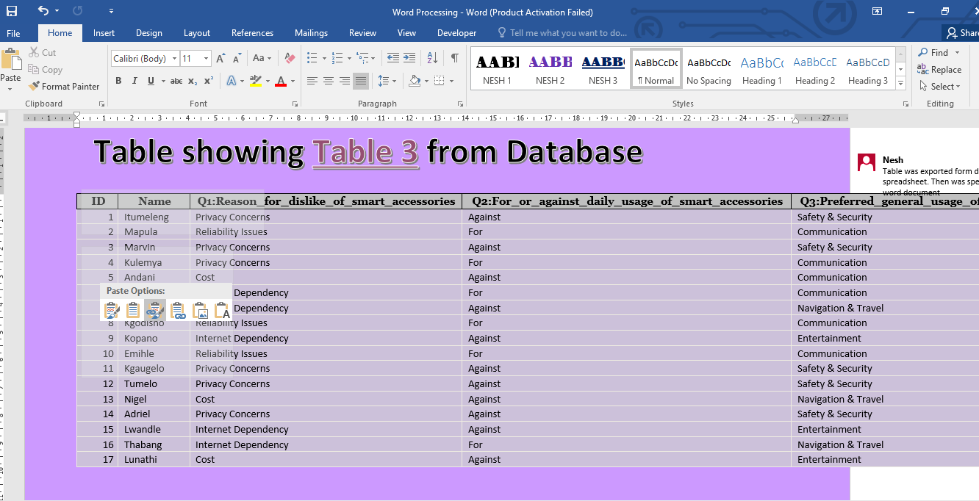

Figure 18 Proof of paste link

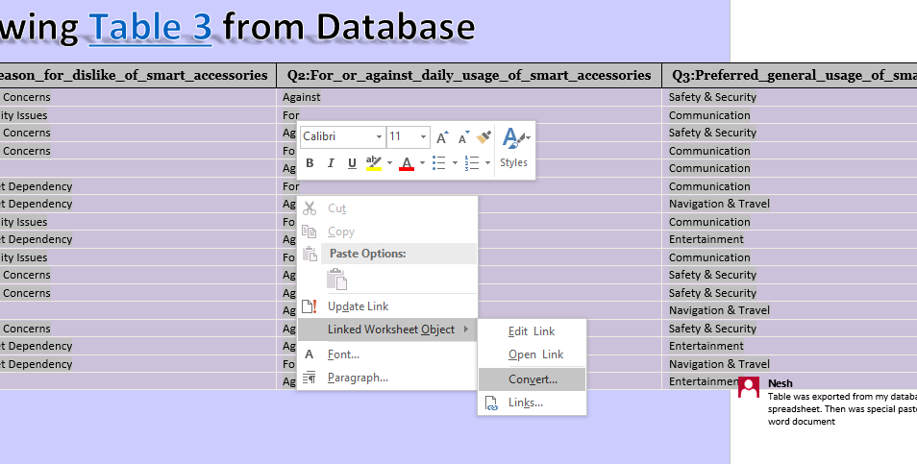

Figure 19 Covert ion of table into icon

APPENDICES

addendum 1/folder structure

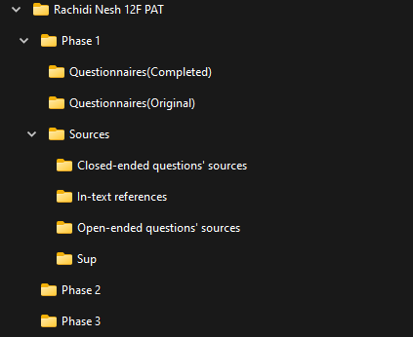

Figure 20 Screenshot of folder structure

Addendum 2/declaration of authenticity

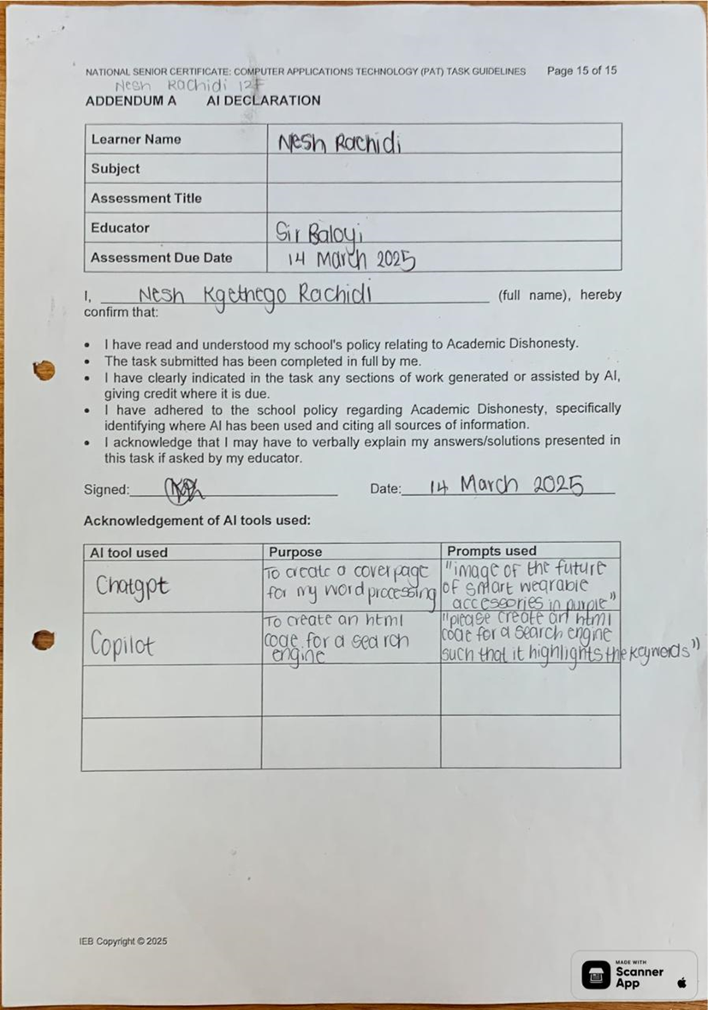

“please create an html code for a navigation button” “please display an example of a frame” “please display an example of what a banner html tag looks like”

To create a html code for a frame, navigation button and banner

Figure 21 Scanned image of AI declaration

Addendum 3/accuracy

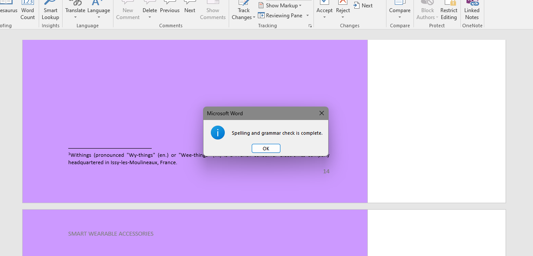

Figure 22 Screenshot of completed spelling and grammar check

BIBILIOGRAPHY

references

*9 Wearable Smart Accessories For Your Everyday Lifestyle.* 2023. [Film] s.l.: Trends Place.

Allen, D., 2023. *How do fitness trackers and wearables measure vital signs?.* [Online]   
Available at: https://www.androidpolice.com/fitness-trackers-smartwatches-meaure-vitals-explainer/  
[Accessed 14 March 2025].

Almuraqab, N. A. S., 2021. Determinants that Influence Consumers’ Intention to Purchase Smart Watches in the UAE: A Case of University Students. *Astes,* 6(1), pp. No 1249-1256.

Anon., n.d. *Lowest Radiation Cell Phones of 2025 (Low SAR Ratings),* s.l.: s.n.

Carreel, E., Huthcings , C. & Potter, F., n.d. *Withings Withings,* France: s.n.

I. et al., 2025. *Questionnaire* [Interview] (11-13 March 2025).

Lwandle, et al., 2025. *Questionnaire* [Interview] (11-13 March 2025).

*NFC vs RFID, What' s the difference.* 2023. [Film] s.l.: s.n.

techlywse, 2024. Smart Devices: Features, Advantages & Disadvantages. *Emerging Tech*, 23 June.

Wikipedia, 2020. Sustainable design. *Wikipedia -The Free Encyclopedia,* December.

Wikipedia, 2024. *Talk:Pulse Watch,* s.l.: s.n.

Yasar, K. & Wigmore, I., n.d. *TechTarget.* [Online]   
Available at: https://www.techtarget.com/searchmobilecomputing/definition/wearable-technology#:~:text=Wearable%20technology%20is%20any%20kind,clothing%20or%20elements%20of%20clothing.  
[Accessed 12 March 2025].

1. Nesh’s word processing document
2. Kinza Yasar is a technical writer in the WhatIs group at TechTarget.
3. Withings (pronounced "Wy-things" (en.) or "Wee-things" (fr.) is a French consumer electronics company headquartered in Issy-les-Moulineaux, France.